Task 1: Grade Checker

Objective
The objective of this task is to write a Python program that accepts a student's score as input and displays the corresponding grade using conditional statements.

Grading Criteria
The program uses the following grading rules:
Score Range | Grade
90–100 | A
80–89.99 | B
70–79.99 | C
60–69.99 | D
Below 60 | F
Scores outside the range of 0 to 100 are treated as invalid.

Implementation
The program is saved as `grade_checker.py`.
The `input()` function accepts the score from the user. The `float()` function converts the input into a numeric value. The program uses if, elif, and else statements to check the score against the grading criteria.
Exception handling with try and except prevents the program from terminating unexpectedly when the user enters non-numeric input.

Sample Execution
Command:
python grade_checker.py
Sample Output:
Enter your score (0-100): 95
Your grade is: A
Another test case:
Enter your score (0-100): 75
Your grade is: C

Screenshot Evidence
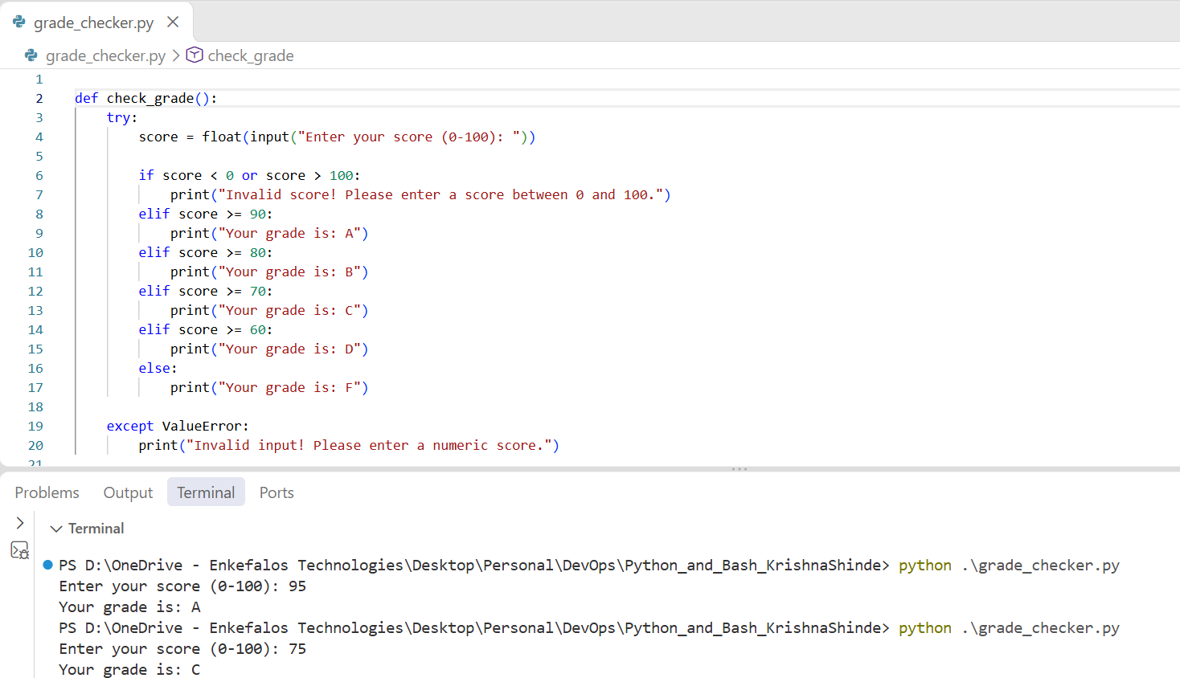

Result
The program successfully determines the appropriate grade based on the score entered by the user. It demonstrates the use of conditional statements, input handling, numeric conversion, and basic exception handling.

Task 2: Student Grades

Objective
The objective of this task is to create a student grade management program using a Python dictionary. The program allows the user to add students, update existing grades, and display all student records.

Implementation
The program is saved as student_grades.py.
A Python dictionary is used to store student names as keys and grades as values. For example:
students = {
"Amit": "A",
"Priya": "B",
"Rahul": "C"
}
The program provides a menu with the following options:
- Add a new student.
- Update an existing student's grade.
- Display all student grades.
- Exit the program.
The program uses a while loop to display the menu repeatedly until the user chooses to exit.
The if, elif, and else statements handle the user's menu selection. The in operator checks whether a student already exists in the dictionary. Dictionary assignment is used to add new records and update existing grades. The items() method is used to display student names and their grades.
The program also validates the entered grade and checks for duplicate student names.

Sample Execution
Command:
python student_grades.py
Sample Output:
===== Student Grades Manager =====
1. Add a new student
2. Update an existing student's grade
3. Display all student grades
4. Exit

Enter your choice (1-4): 3

----- All Student Grades -----
Amit: A
Priya: B
Rahul: C
Example of adding a student:
Enter your choice (1-4): 1
Enter student name: Neha
Enter student grade (A/B/C/D/F): A
Student Neha added successfully.
Example of updating a grade:
Enter your choice (1-4): 2
Enter student name to update: Priya
Enter the new grade (A/B/C/D/F): A
Grade updated successfully for Priya.

Screenshot Evidence
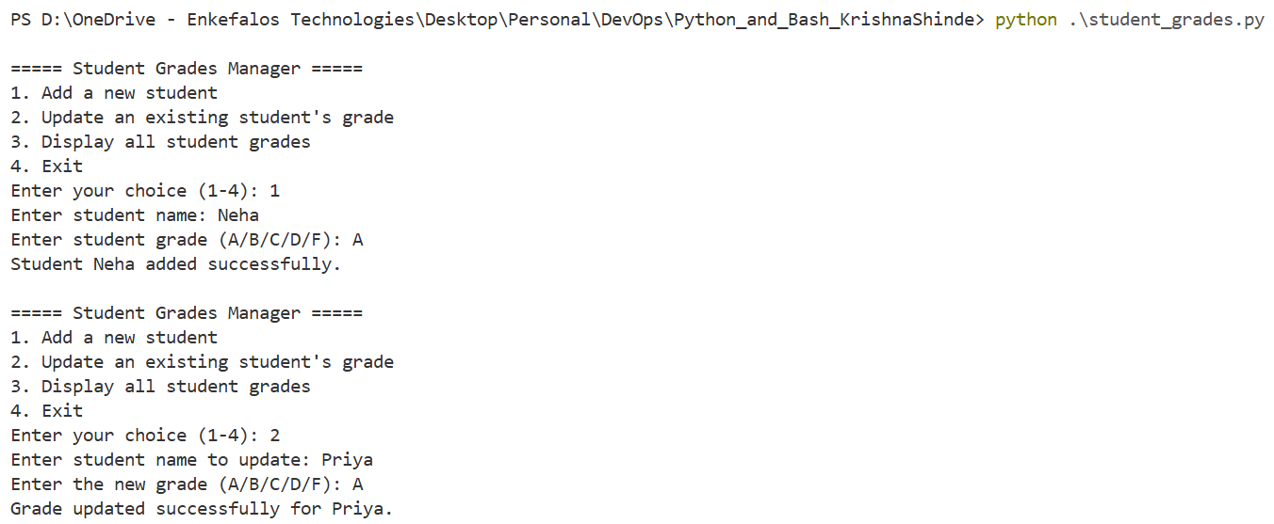
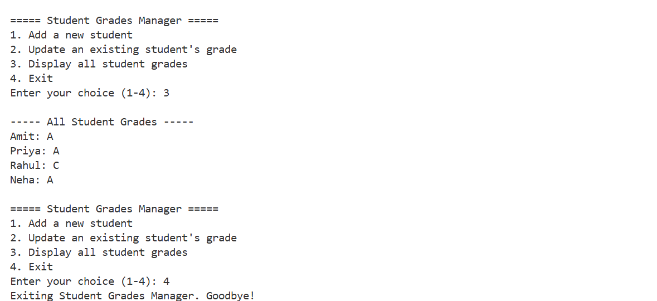
Result
The program successfully manages student grades using a dictionary. It demonstrates dictionary operations, conditional statements, loops, membership testing, and user input validation.
Student records are stored in memory and reset to their initial values when the program restarts.

Task 3: Write to a File

Objective
The objective of this task is to create a text file and write content to it using Python file handling functions.

Implementation
The program is saved as write_file.py.
The program uses the open() function to create or open a file named sample.txt. The file is opened in write mode using "w".
The write() method writes text into the file. The with statement ensures that the file is closed automatically after the write operation is completed.
The program also uses exception handling to report file-related errors.
Sample Execution
Command:
python write_file.py
Sample Output:
Content written successfully to 'sample.txt'.
After execution, the file sample.txt contains the following content:
Welcome to the Python and Bash DevOps Assignment.
Task 3: Writing data to a text file.
Python makes file handling simple and efficient.

Explanation of File Operations
- open("sample.txt", "w"): Opens the file in write mode and creates it if it does not exist.
- file.write(content): Writes the specified text into the file.
- with: Manages the file resource and closes it automatically when the block finishes.
- encoding="utf-8": Specifies the text encoding.
Note: Write mode replaces the existing file content when the program runs again.
Screenshot Evidence
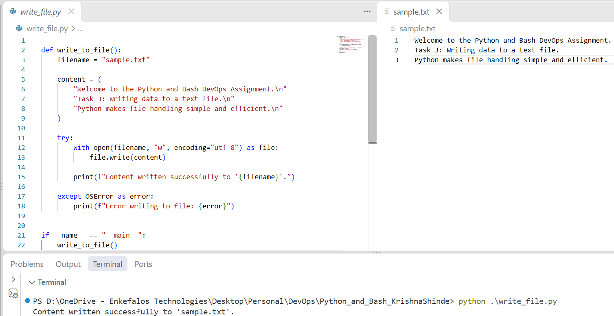

Result
The program successfully creates the text file and writes the specified content. This task demonstrates basic file creation, writing operations, resource management, and file error handling.

Task 4: Read from a File

Objective
The objective of this task is to open an existing text file, read its contents using file.read(), and display the contents in the terminal.

Implementation
The program is saved as read_file.py.
The program opens sample.txt in read mode using "r". The read() method retrieves the entire file content as a string. The print() function displays the retrieved content in the terminal.
The program also handles the FileNotFoundError exception in case the file does not exist.

Sample Execution
Command:
python read_file.py
Sample Output:
----- File Contents -----
Welcome to the Python and Bash DevOps Assignment.
Task 3: Writing data to a text file.
Python makes file handling simple and efficient.

Explanation of File Operations
- open("sample.txt", "r"): Opens the existing file in read mode.
- file.read(): Reads the entire contents of the file.
- print(content): Displays the contents on the terminal.
- FileNotFoundError: Handles the situation where the specified file cannot be found.
The write_file.py program should be executed before running read_file.py to ensure that sample.txt has been created.

Screenshot Evidence
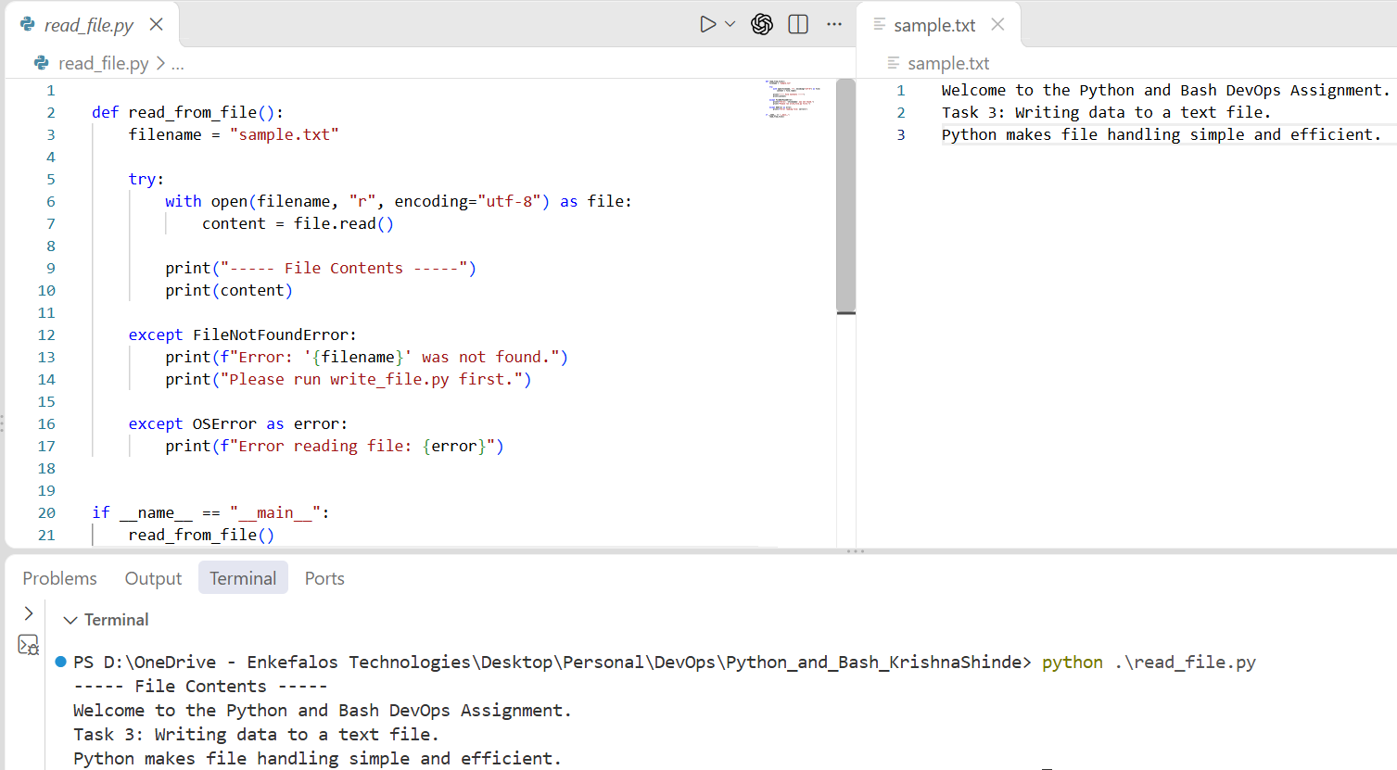

Result
The program successfully reads and displays the content stored in sample.txt. This task demonstrates file reading, string handling, and basic file error handling in Python.

